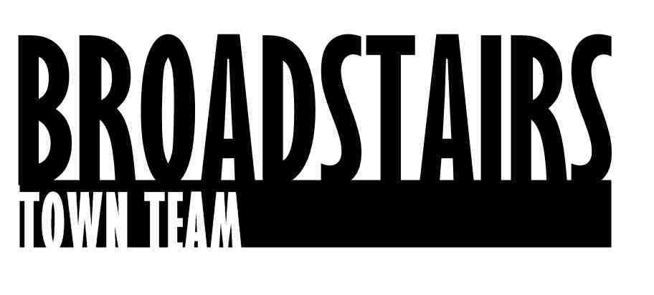

Press Release from Broadstairs Town Team

Date : 9.3.16
Subject : Harbour and Seafront Group to join forces with Town Team
Intro :
Members from the recently-formed Broadstairs Harbour and Seafront Group have just
joined forces to form the Broadstairs Town Team Harbour Group.

The volunteer-run Town Team was formed in 2013 and has worked on multiple projects in and around Broadstairs, in conjunction with local special interest groups, businesses, schools and colleges.

Facts:

4 projects in the pipeline for 2016 :

-Cleaning and then re-painting the Zig zag steps in the centre of Viking Bay.
-Restoration and cleaning of memorial benches in and around Broadstairs in conjunction with apprentices from local ‘Constructing your future’ project.
- Surveying and then planning the restoration of The Old Lookout on Broadstairs Jetty
- Completion of Phase 1 and then planning Phase 2 of the sand removal from Viking Bay planned for 2017.

Quotes :

Kerry Millett from Town Team said
‘ The opportunity to work together and pool our knowledge, experience and contacts is a no-brainer. The Harbour group have already made such great progress with the removal of excess sand on Viking Bay, and there are already 3 other projects that we are planning to work on collectively.
John Nicholls – from the Harbour Group added:
‘ With so many interested parties feeling passionate about projects in Broadstairs, particularly the Old Look Out as one of our most iconic landmarks, I’m certain we can all harness that enthusiasm and find ways of funding and delivering the best for Broadstairs together’.
Ends.

For further information, go to www.broadstairstownteam.org.uk or contact :
Kerry Millett
Chair, Broadstairs Town Team - 07976365741

