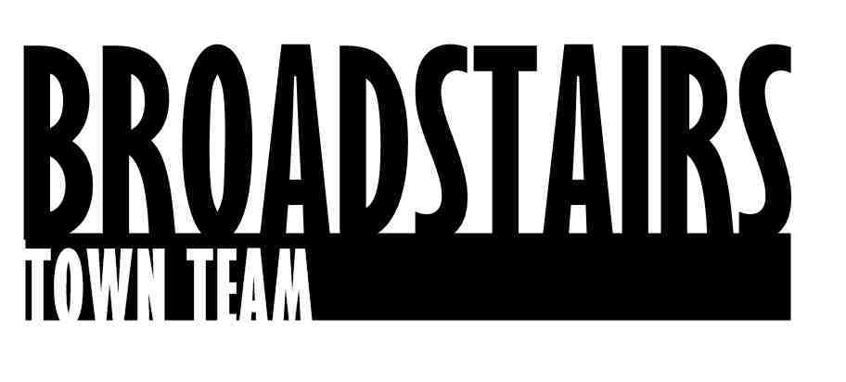

Press Release from Broadstairs Town Team

Date : 21.3.16
Subject : Broadstairs Town Team ‘Brush Up’ Team Spring Clean Viking Bay a hug success
Intro : In preparation for the Easter break, Broadstairs Town Team called on local volunteers for a ‘Spring Clean on Viking Bay’.
Activities included :
Clearing the boardwalk, weeding and working on the main steps down to the beach, in preparation for the painting planned for April, plus Litterpicking, sweeping and weeding in and around the Bay and the Undercliff and graffiti removal.
The newly-formed Town Team Harbour and Seafront group were out in force, and refreshments provided free by The Viking Bay Café and very welcome bacon sandwiches sponsored by the Oakleaf cleaning Company.
Date of event : 19.3.16 10.00 a.m
Pictures : See attached files.
Facts: Over 50 volunteers turned out to support the Town Team Spring Clean for Viking Bay initiative ahead of the Easter break.

A lovely sunny Sunday that followed on 20th saw many, many visitors already enjoying the newly tidied beach.

Quotes :
Wendy Carr, Trustee of Town Team who runs the Brush Up projects said
‘We had a wonderful turn out of past and lots of new volunteers from Broadstairs.
The more people that volunteer to help, the more we are able to achieve together for the town’

For further information, go to www.broadstairstownteam.org.uk or contact :
Kerry Millett
Chair, Broadstairs Town Team - 07976365741

