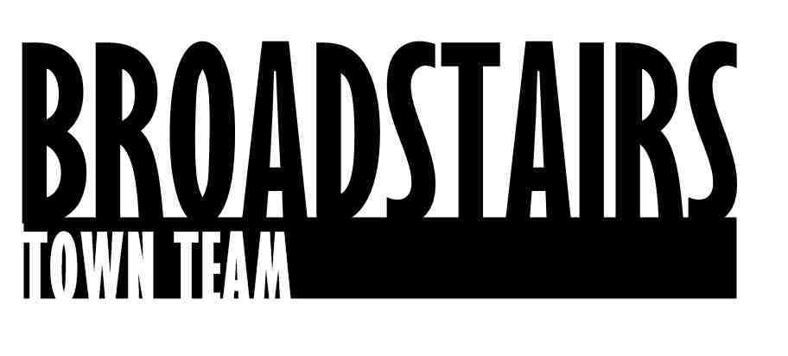

Press Release from Broadstairs Town Team

Date : 6.3.16
Subject : Broadstairs and St. Peter’s groups work together to clean up town.
Key Dates : Friday 4th & Saturday 5th March
Intro :
Volunteers from Broadstairs Town Team ‘Brush Up’ team, St. Peter’s Churchyard group, The Neighborhood engagement team plus volunteers from St.George’s and Bradstowe Schools got together last weekend in various locations in and around Broadstairs and St. Peters, as part of the Clean for the Queen initiative. Bags had been provided from the campaign, and over 100 people turned up to help tidy our town.

Quotes :
Sue Wall Secretary of the Neighborhood Engagement Meetings :
‘It’s amazing the range of things that people throw away, we have collected so much today, and are happy to have helped to make Broadstairs a nicer place to live in and visit. What would be lovely to see as a legacy from this project is that more and more people either use bins provided or take their rubbish home with them’
Wendy Carr from Town Team added :
‘It was great that so many people came to help. Community working together is always what we’re about and this weekend was a great testament to that. To see people from all generations working towards the same goal was very encouraging.’

For further information, go to www.broadstairstownteam.org.uk or contact :
Kerry Millett
Chair, Broadstairs Town Team - 07976365741

Images attached separately.

