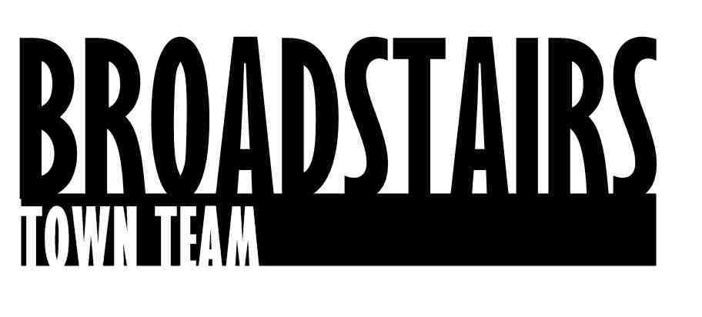
DRAFT!! Press Release from Broadstairs Town Team
Date : 4.5.16
Subject : Restoration of Memorial benches in Broadstairs carried out by apprentices looking for employment locally.
Intro :
Apprentices from the ‘Constructing your future’ group have restored several memorial benches in and around Broadstairs.
Working with the Town Team Harbour and Seafront group on the project, the young people have been sanding, painting and re-varnishing many of the older benches that are on the Harbour Arm and beyond in their own time.

The volunteer-run Town Team was formed in 2013 and has worked on multiple projects in Broadstairs and St. Peter’s, in conjunction with local special interest groups, businesses, schools and colleges.

Facts:

The restoration of the benches marks the start of the 4th project being delivered by The Town Team Harbour and Seafront group.
Work has already begun on phased sand removal in Viking Bay, to facilitate boats moving back into the Harbour, and the repainting of the central ‘Zig zag’ staircase down to the beach from the promenade is now complete.
The team are also in the process of restoring key elements of the Old Look Out on the jetty, working with carpentry students from East Kent College and other local volunteers.

Quotes :
Tony Elliot, from Constructing your future said :
‘The ultimate goal is for all of our young people to find employment. This sort of volunteer activity gives them all an opportunity to show what they have learned through the programme. We aim to get them as much hands-on experience a possible, so that they are ready to take on positions within the building trades locally and regionally. We have a sign which says ……………. We would love to hear from local building Companies looking to help them into their first jobs in construction’
John Nicholls – from the Harbour Group added:
‘ The skills these young people have will be an asset to any local Company. This project is a chance for then to showcase those skills and enthusiasm to potential local employers. It’s great that they are giving their time to help the Town Team and the town, and particularly benches that are memorials to many lost loved ones. We hope that publicity surrounding the project will mean that more people know what great skills they have to offer’
Ends.
For further information, go to www.constructingyour future.org.uk or contact :
Tony Elliot tonyelliot@constructingyouirfuture.co.uk or on 07951943464

