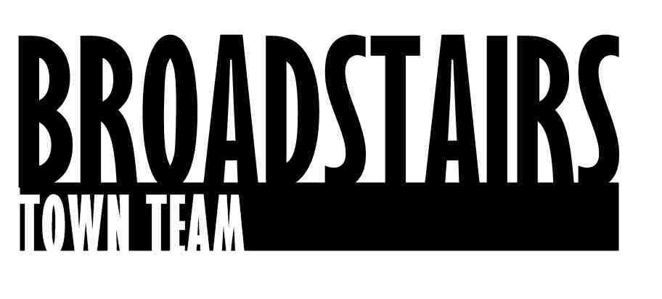

Press Release from Broadstairs Town Team

Date : 22.4.16
Subject : Viking Bay stairs restoration
Summary : Broadstairs Town Team Harbour Group Co-ordinate refurbishment of main Viking Bay staircase.
Work is due to be completed this week on the refurbishment of the main staircase from the Promenade down to Viking Bay.
The project which has been paid for by a crowd-funding campaign via donations from local businesses and residents was co-ordinated via Thorley Taverns and the project itself has been managed by the Harbour Group from Broadstairs Town Team, with a local Contractor commissioned to do the work.
Remedial work on the render, then anti fungal treatment and re-painting has taken approximately 2 weeks.
The team also has plans to work on a major refurbishment plan for The Old Look Out or Harbour Master’s House on the jetty on Viking Bay, as part of a Coastal Communities Team bid.

Quotes :
Andrew Rogers from the Town Team Harbour and Seafront group said :
‘It’s been fantastic how so many local people and businesses have contributed funds towards the work, it’s such a focal point for Viking Bay, and great that we managed to get the work done before the season really kicks in. We’d like to Thank everyone for their generosity so far, and if anyone is interested in donating funds or helping the team towards our next project, The Old Lookout building – we’d love to hear from them’

For further information, go to: http://www.broadstairstownteam.org.uk/activities/harbour-seafront-group/
or contact :Andrew Rogers

