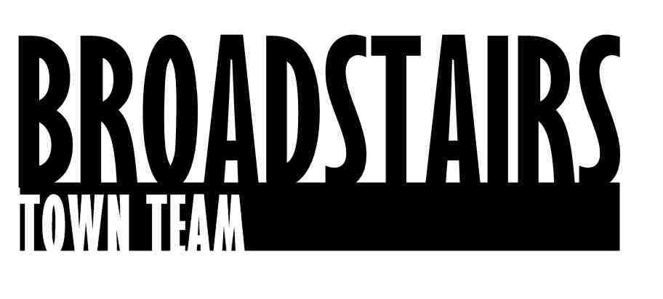
Press Release from Broadstairs Town Team
Date : 30.5.16 Subject : Broadstairs Train Station Facelift
Summary : Broadstairs Town Team Station Crew group complete Phase 1– Planters along the Train Station Entrance
Wooden planters hand made by The Town Shed have been installed along the station entrance.
The project that has been sponsored by local businesses, organisations and residents has been driven by the newly-formed ‘Station Crew’ group from Broadstairs Town Team.
The Station Crew are all local volunteers and have worked with Network Rail and Southeastern to improve the look of the Station for visitors and local commuters. They will maintain the planters and update the new community noticeboard, which was installed inside the ticket hall as part of the project.
Local businesses and groups that sponsored the project to date include Broadstairs Carpets, WA Hazell Butchers, Cleverdons Accountants, The Old Bakehouse, Broadstairs Rotary Club and The Broadstairs Society.
The team also has plans to continue with Phase 2 of the facelift, which include the Station Platforms and exit area. If you would like to volunteer or help sponsor Phase 2 please contact denise@broadstairstownteam.org.uk
Quotes :
Rob Kenyon, Director of Community Services at TDC said:
'It's fantastic to see the community coming together in Broadstairs to create such a beautiful welcome to visitors and commuters alike. The town shed provides an invaluable resource, which not only adds civic pride and creates a tangible difference to the town, but also helps increase the volunteers' health and wellbeing'

Denise Martin-Harker from The Station Crew group said:
‘It’s been wonderful to work with such a great group of people who have all come together to do something positive for Broadstairs. Thank you to all our local sponsors, The Town Shed and our lovely volunteers who made this project come to life. We hope everyone enjoys the new look and would love to hear from anyone interested in helping us with Phase 2”

Gary Gould from The Old BakeHouse said:
‘Thank you to the Town Team for involving us in the project and for working to keep Broadstairs looking good for residents and visitors alike. We hope people appreciate the improvements and support Phase 2’

For further information please contact : denise@broadstairstownteam.org.uk or on : 07826 099006 Ends….

