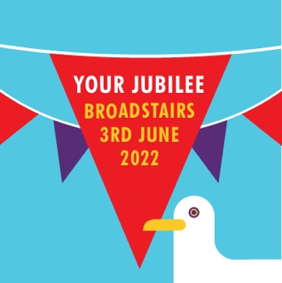

Hello, I would like to enter my artwork for the ‘Backdrop competition’ for The Broadstairs Platinum Jubilee Celebrations

My Name is : …………………………………………………………………………………….

I am ……… years old

My contact details are : Email :
Telephone :
My responsible Adult’s name :

I attend………………………………………………………………school

If I win, I would love to use my voucher to buy……………………….. as I would like to make :

………………………………………………………………………………………………………………..

Office use: Entry No. : QJ……………………………………... Other : …………………………………

